Control Structures in C
In C, control structures are used to control the flow of execution of statements. They are divided into three categories:
1. Decision-making (Selection) → if, if-else, if-else if, nested-if, switch,
2. Jump (Branching) → break, continue, goto
3. Loops (Iteration) → for, while, do-while
1. Decision-making /Selection Structures -
1. Syntax of if in C:

if (condition) {
// Code to execute if condition is true
}
Statement x;
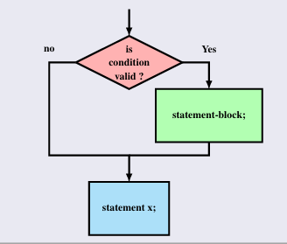
2. Syntax of if-else in C:

if (condition) {
// Code to execute if condition is true
} else {
// Code to execute if condition is false
}
Statement x;
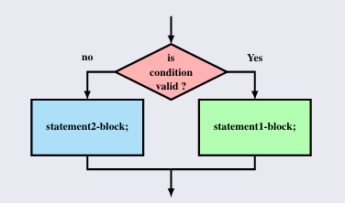

Example of if-else:
#include <stdio.h>

int main() {
int num = 10;

if (num > 0) {
printf("The number is positive.\n");
} else {
printf("The number is negative or zero.\n");
}

return 0;
}

3. Syntax of if-else if-else (if-else ladder) in C:

if (condition1) {
// Code to execute if condition1 is true
} else if (condition2) {
// Code to execute if condition2 is true
} else if (condition3) {
// Code to execute if condition3 is true
} else {
// Code to execute if all conditions are false
}
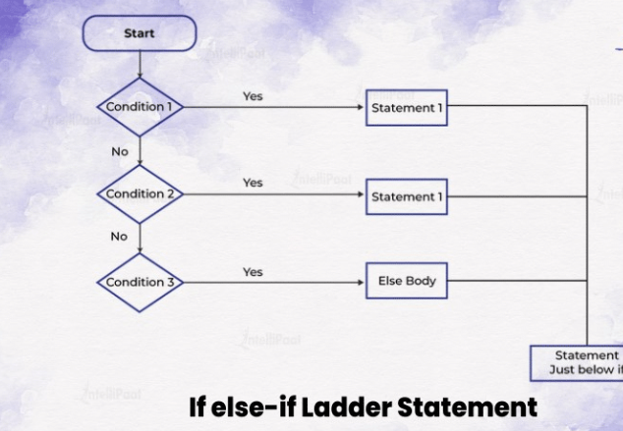
Example of if-else if-else (if-else ladder):

#include <stdio.h>

int main() {
int num = 0;

if (num > 0) {
printf("The number is positive.\n");
} else if (num < 0) {
printf("The number is negative.\n");
} else {
printf("The number is zero.\n");
}

return 0;
}

Practice Problems 👍
1. //Assign student the grade according to its total mark
//Mark > 90 : ’O’ //Mark > 80 <= 90 : ’A’ //Mark > 70 <= 80 : ’B’ //Mark > 60 <= 70 : ’C’ //Mark > 50 <= 60 : ’D’ //Mark < 50 : ’F’
2. Write a C program to calculate an electricity bill based on the following consumption slabs:
- For the first 100 units: ₹5 per unit.
- For the next 100 units (101-200): ₹7 per unit.
- Above 200 units: ₹10 per unit.
For example, if the user consumes 250 units:
- The first 100 units are charged at ₹5 per unit.
- The next 100 units are charged at ₹7 per unit.
- The remaining 50 units are charged at ₹10 per unit.
Use an if-else ladder to calculate the bill based on the consumption slab.

3. Write a C program that takes three integer values as the lengths of a triangle's sides and determines the type of triangle:
- If all sides are equal, it's an Equilateral Triangle.
- If two sides are equal, it's an Isosceles Triangle.
- If no sides are equal, it's a Scalene Triangle.
- If the sum of any two sides is not greater than the third side, print "Not a valid triangle".
4 Syntax of Nested if in C:
Nested if statement an if statement with another if statement as its true task or its false task.
If (boolean_expression 1)
{
if( boolean_expression 2)
{ Statement-Block 1; }
else { Statement-Block 2; }
}
else
{ if( boolean_expression 2)
{ Statement-Block 3; }
else { Statement-Block 4; }
}
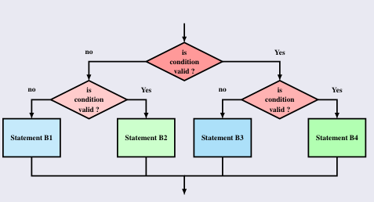
Program to find maximum integer among 3 input
#include<stdio.h>
int main(void){
int a,b,c, max;
printf("Eneter the 3 numbers :");
scanf("%d %d %d", &a, &b, &c);
if(a>=b){
if(a>=c){
max = a;
}
else
{
max=c;
}
}
else{
if(b>=c)
{
max = b;
}
else
{
max=c;
}
}
printf("%d is max among %d, %d, and %d\n", max, a, b, c);
}
6. Syntax of Switch in C:
switch ( controlling expression ) {
case label_set_1:
statements_1
break;
case label_set_2:
statements_2
break;
...
...
case label_set_n:
statements_n
break;
default:
statements_d
}
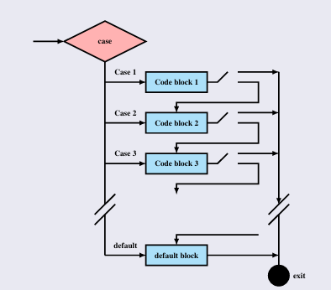
Questions
- Write a program to implement Calculator with +,-*,/,% (consider special character as input)
// Program to create a simple calculator
#include <stdio.h>

int main() {
char operation;
double n1, n2;

printf("Enter an operator (+, -, *, /): ");
scanf("%c", &operation);
printf("Enter two operands: ");
scanf("%lf %lf",&n1, &n2);

switch(operation)
{
case '+':
printf("%.1lf + %.1lf = %.1lf",n1, n2, n1+n2);
break;

case '-':
printf("%.1lf - %.1lf = %.1lf",n1, n2, n1-n2);
break;

case '*':
printf("%.1lf * %.1lf = %.1lf",n1, n2, n1*n2);
break;

case '/':
printf("%.1lf / %.1lf = %.1lf",n1, n2, n1/n2);
break;

// operator doesn't match any case constant +, -, *, /
default:
printf("Error! operator is not correct");
}

return 0;
}
- Write a program for to check whether the entered character is Vowels or Consonants
For Loop :
Syntax :
for (initialization; condition; update) {
// Code to be executed repeatedly
}
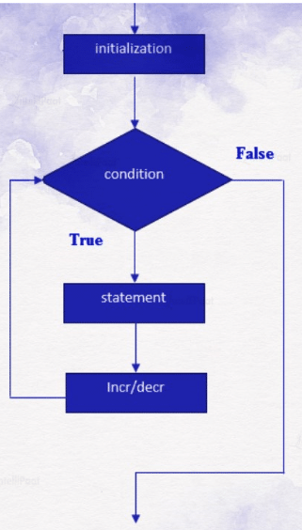
Example :
#include <stdio.h>
int main() {
int i;
// for loop to print numbers from 1 to 5
for (i = 1; i <= 5; i++) {
printf("%d\n", i);
}
return 0;
}

Questions
1.Write a c program to Find the Factorial of a Number.
2.Write a C program that calculates and prints the sum of the digits of a given integer n using a for loop. The number can be positive or negative.
While Loop :
Syntax:
while (condition) {
// Code to be executed as long as condition is true
//Increment/decrement
}
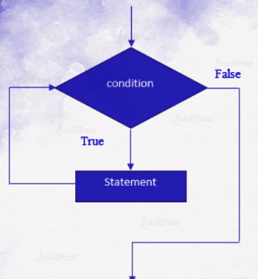
Example
#include <stdio.h>
int main() {
int i = 0;
while (i < 5) {
printf("i = %d\n", i);
i++; // Increment the value of i
}
return 0;
}
Questions:
1.Write a program that reverses the digits of a number provided by the user.
2.Write a program using a while loop to count the number of digits in a number provided by the user.
Do While :
Syntax :
do {
// Code to be executed
//increment /decrement
} while (condition);
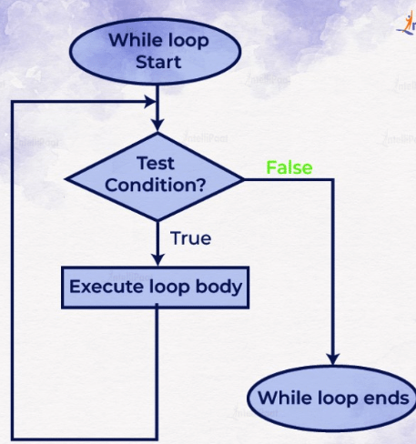
Example :
#include <stdio.h>
int main() {
int i = 1;
do {
printf("i = %d\n", i);
i++;
} while (i <= 5);
return 0;
}
Questions 👍
1.Write a C program using a do-while loop to find the sum of all even numbers between two given integers start and end.
Example input:
start = 3, end = 10
Expected output:
Sum of even numbers between 3 and 10 is 28

2.Write a C program using a do-while loop to check if a given integer is a palindrome (i.e., it reads the same forward and backward).
Example input:
Number: 121
Expected output:
121 is a palindrome.
Break Statement :
The break statement is used to exit a loop or switch statement prematurely. When a break is encountered, control immediately exits the loop or switch, and execution continues with the next statement after the loop or switch.
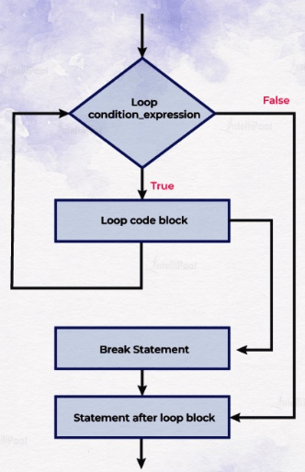
Syntax
#include <stdio.h>
int main() {
int i;
for (i = 1; i <= 10; i++) {
if (i == 5) {
break; // Exit the loop when i is 5
}
printf("%d ", i);
}
return 0;
}
Continue Statement :
The continue statement is used to skip the remaining code inside a loop for the current iteration and move directly to the next iteration. It doesn’t exit the loop but skips the rest of the code in the loop body and continues with the next iteration.
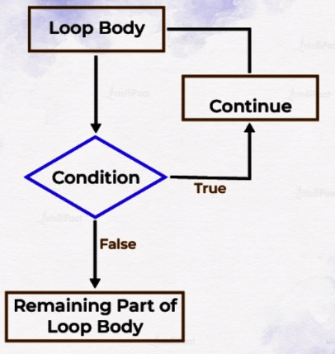
Syntax :
#include <stdio.h>
int main() {
int i;
for (i = 1; i <= 10; i++) {
if (i == 5) {
continue; // Skip the rest of the loop body when i is 5
}
printf("%d ", i);
}
return 0;
}
goto Statement :
The goto statement allows a program to jump to a labeled statement elsewhere in the code. The label is an identifier followed by a colon, and it marks a specific point in the code.
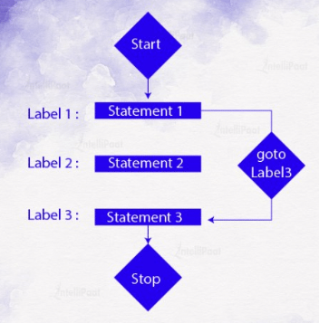
#include <stdio.h>
int main() {
int i = 0;
loopStart:
if (i < 5) {
printf("%d\n", i);
i++;
goto loopStart; // Jump back to the labeled statement
}
return 0;
}
Q1 (Break Statement)
Write a program in C that reads integers from the user until a negative number is entered. Use a break statement to terminate the loop immediately once the negative number is encountered. Display the sum of all positive numbers entered.
Q2 (Continue Statement):
Develop a C program that prints all numbers from 1 to 50, but uses a continue statement to skip printing the multiples of 5.
Q3 (Goto Statement):
Construct a C program to calculate the factorial of a given number using a loop and a goto statement instead of standard loop control constructs. Ensure that the program validates the input (non-negative integer).
Functions

